**Excel Assignment - 6**

**1. What are the various elements of the Excel interface? Describe how they're used.**

The Excel interface consists of several elements that allow users to perform various tasks and manipulate data. Here are the main elements of the Excel interface and their uses:

1. Workbook: A workbook is a file that contains your spreadsheet data. It is represented by a file name at the top of the Excel window. You can have multiple workbooks open at the same time, and each workbook can contain multiple worksheets.
2. Worksheets: Worksheets are the individual tabs within a workbook. They are used to organize and separate data within the workbook. You can switch between worksheets by clicking on their respective tabs at the bottom of the Excel window.
3. Cells: Cells are the individual rectangular boxes within a worksheet grid. They are identified by their column and row coordinates, such as A1, B2, etc. Cells are used to enter and display data, perform calculations, and store formulas.
4. Ribbon: The ribbon is located at the top of the Excel window and contains multiple tabs, each with various commands and options. The tabs are organized based on different functions, such as Home, Insert, Page Layout, Formulas, Data, Review, and View. The ribbon provides easy access to a wide range of tools and features in Excel.
5. Formula Bar: The formula bar is located above the worksheet grid and displays the contents of the currently selected cell. It can be used to enter or edit data, including formulas and functions.
6. Name Box: The name box is located next to the formula bar and displays the reference or name of the selected cell, range, or named range. You can also use the name box to navigate to a specific cell or range by typing its reference.
7. Column and Row Headers: The column headers are the letters (A, B, C, etc.) displayed at the top of each column in the worksheet grid. The row headers are the numbers (1, 2, 3, etc.) displayed on the left side of each row. They are used to identify and reference specific columns and rows in Excel.
8. Navigation Buttons: The navigation buttons consist of the scroll bars and the sheet tabs at the bottom of the Excel window. The scroll bars allow you to navigate vertically or horizontally within a worksheet when the data extends beyond the visible area. The sheet tabs enable you to switch between worksheets in the workbook.
9. Status Bar: The status bar is located at the bottom of the Excel window and provides information about the current status of the workbook and any ongoing actions, such as calculation progress, mode indicators (e.g., Caps Lock), and zoom level.

These elements collectively form the Excel interface, enabling users to enter, manipulate, and analyze data efficiently. By utilizing these components effectively, you can perform a wide range of tasks, including data entry, formatting, calculations, data analysis, and charting.

**2. Write down the various applications of Excel in the industry.**

Excel is a versatile spreadsheet software that finds numerous applications across various industries. Here are some of the common applications of Excel in different sectors:

1. Finance and Accounting: Excel is extensively used in financial analysis, budgeting, forecasting, and financial modeling. It helps in creating balance sheets, income statements, cash flow statements, and other financial reports. Excel's functions and formulas enable complex calculations, financial modeling, and data analysis.
2. Sales and Marketing: Excel aids in managing sales data, customer information, and tracking sales performance. It helps in creating sales reports, sales forecasts, and analyzing customer trends. Excel can also be used for marketing campaign analysis, data segmentation, and lead management.
3. Human Resources: Excel assists HR departments in managing employee data, payroll calculations, attendance tracking, and employee performance analysis. It can be used for creating employee schedules, calculating leave balances, and organizing training programs.
4. Project Management: Excel serves as a valuable tool for project planning, scheduling, and tracking. It can be used to create Gantt charts, project timelines, and task lists. Excel's conditional formatting and data validation features help in monitoring project progress and identifying potential bottlenecks.
5. Data Analysis: Excel is widely used for data analysis tasks such as sorting, filtering, and analyzing large datasets. It provides functions for statistical analysis, regression analysis, and data visualization. Excel's pivot tables and charts help in summarizing and presenting data effectively.
6. Inventory Management: Excel aids in inventory tracking, stock management, and order fulfillment. It enables businesses to create inventory lists, track stock levels, and generate reports on inventory turnover, reorder points, and stock valuation.
7. Research and Data Collection: Excel is often used for organizing and analyzing research data. It can be used to create survey forms, input and validate data, and perform statistical analysis on collected data.
8. Quality Control and Assurance: Excel helps in managing quality control processes by creating checklists, tracking defects, and analyzing quality metrics. It enables businesses to monitor product or service quality and identify areas for improvement.
9. Education and Academia: Excel is extensively used in educational institutions for various purposes. It assists teachers in grading, organizing student data, and creating lesson plans. Excel can be used by students for data analysis, mathematical calculations, and graphing.
10. Operations and Logistics: Excel supports logistics and supply chain management by creating delivery schedules, tracking shipments, and managing inventory. It helps in optimizing routes, calculating transportation costs, and analyzing supply chain performance.

These are just a few examples of the wide range of applications Excel offers across industries. Its flexibility, computational capabilities, and ease of use make it a valuable tool for professionals in diverse fields.

**3. On the ribbon, make a new tab. Add some different groups, insert commands in the groups, and name them according to the commands added. Copy and paste the screenshot of the steps you followed.**

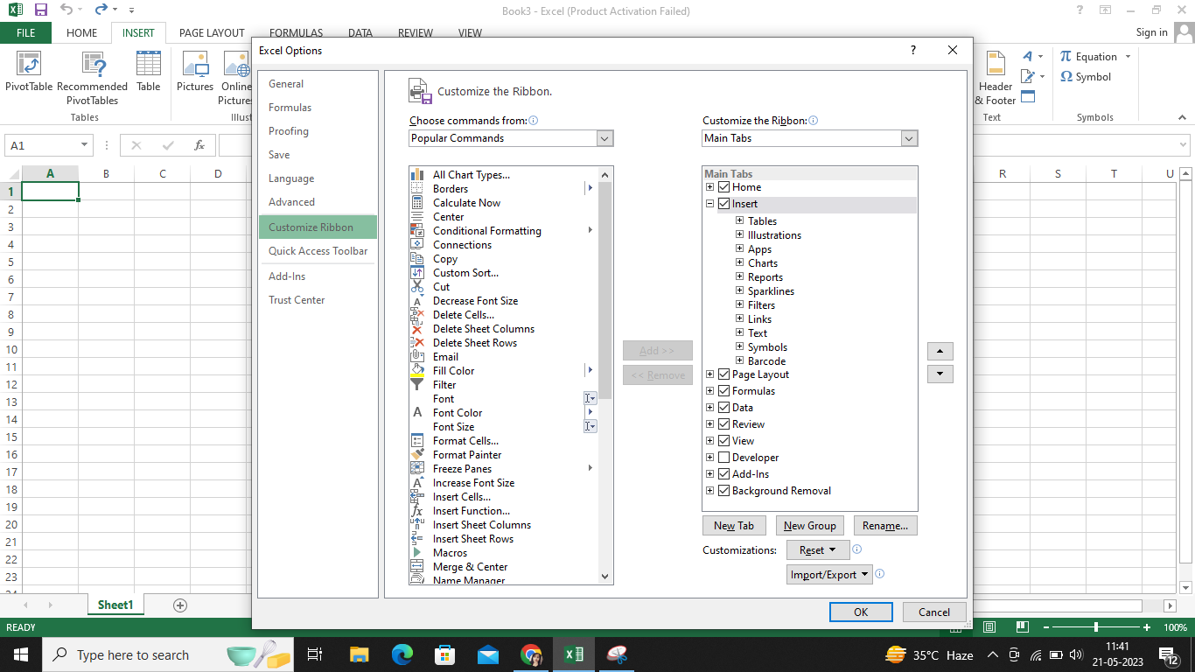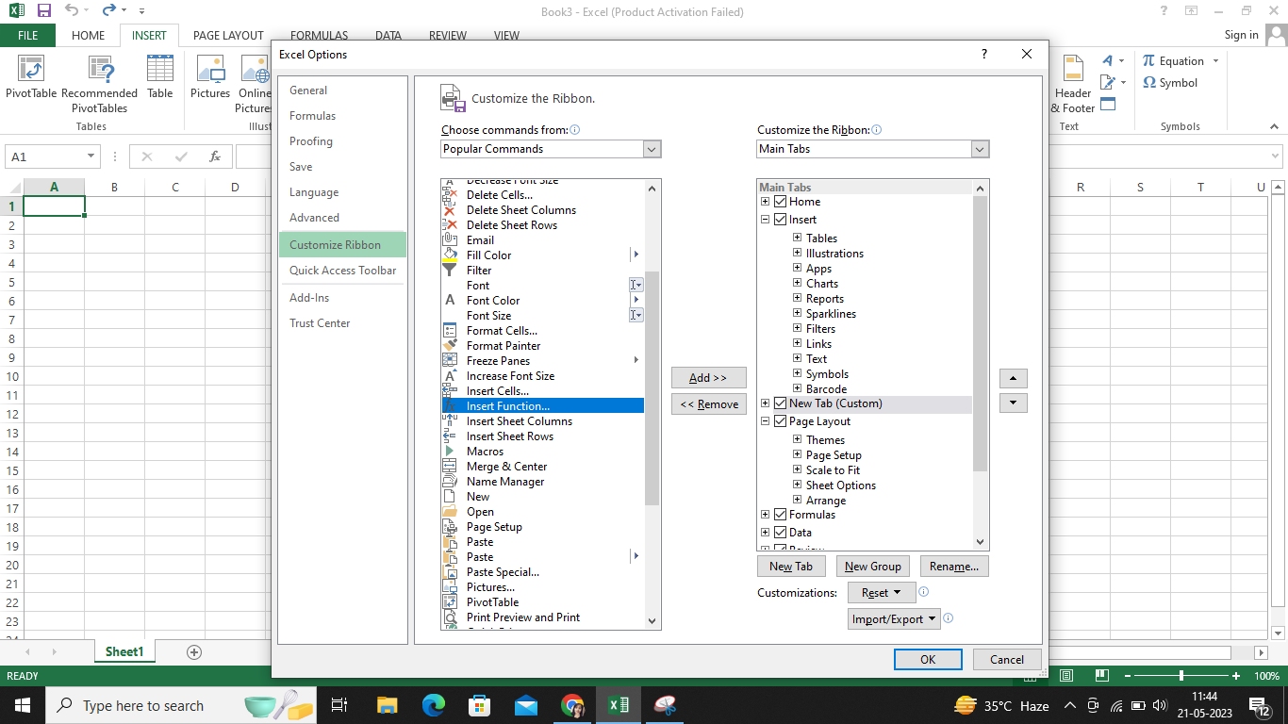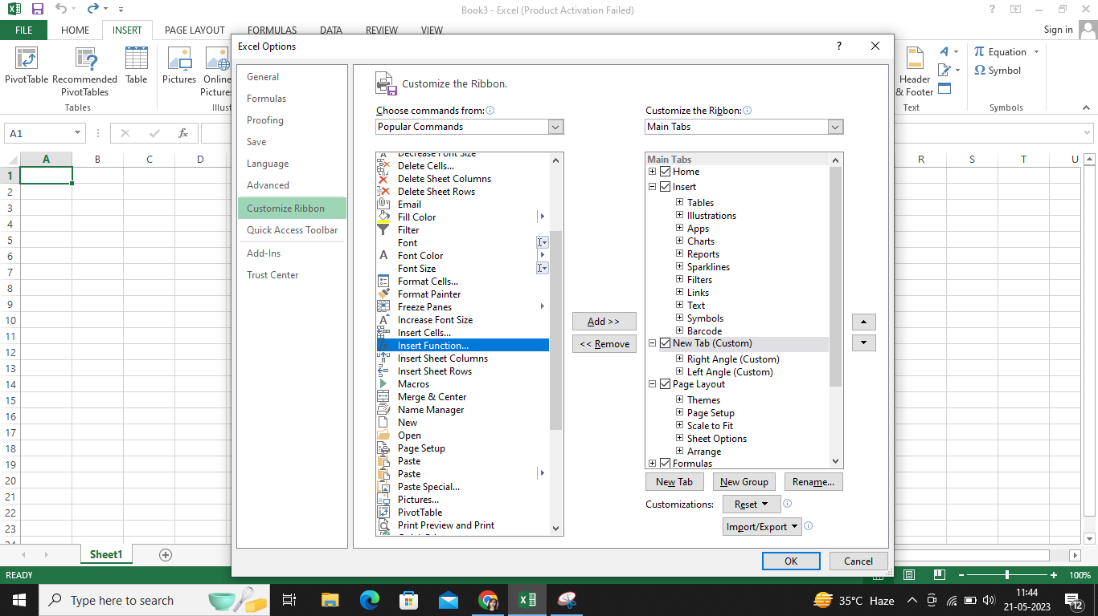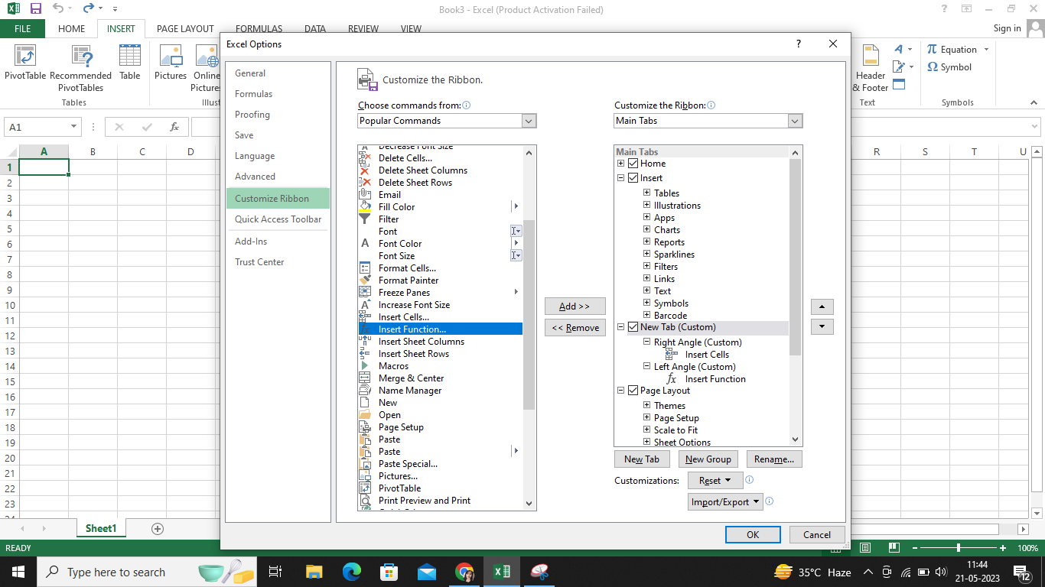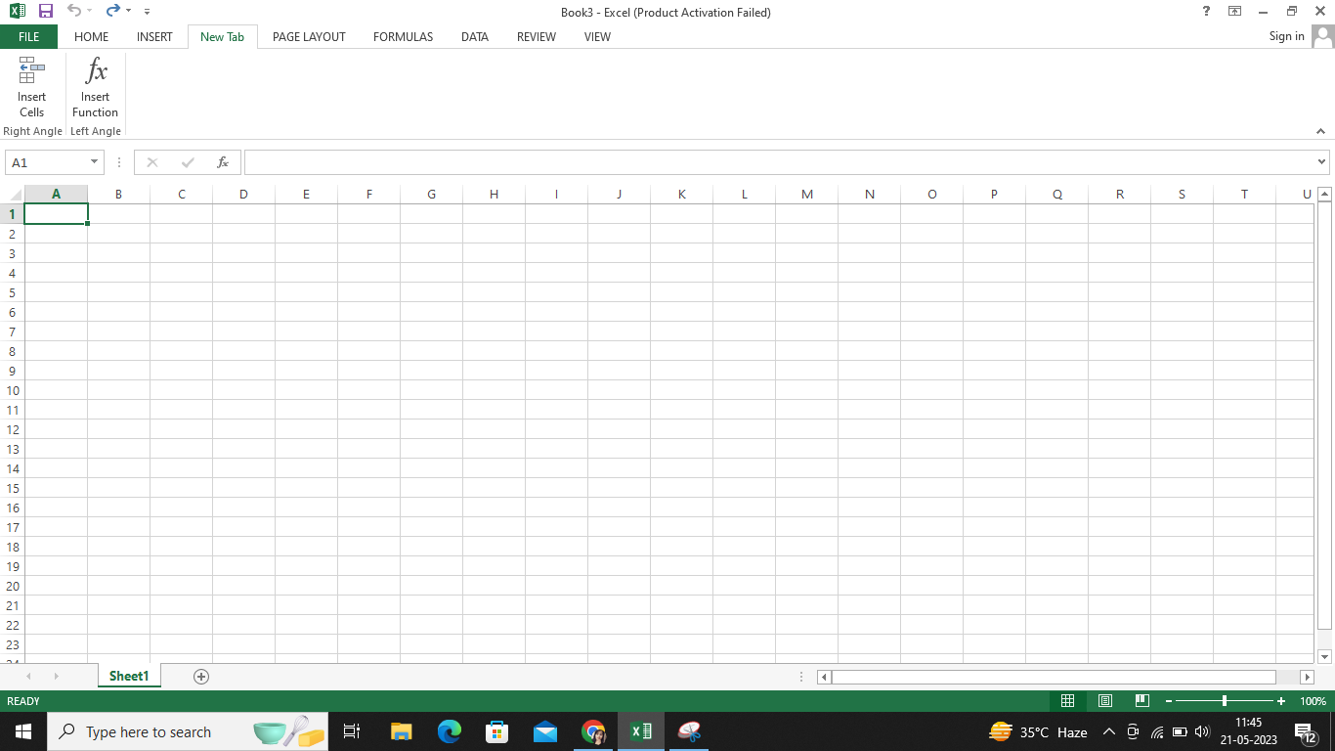

**4. Make a list of different shortcut keys that are only connected to formatting with their functions.**

Here's a list of shortcut keys specifically related to formatting:

1. Ctrl+B: Bold - Applies or removes bold formatting to the selected text.
2. Ctrl+I: Italic - Applies or removes italic formatting to the selected text.
3. Ctrl+U: Underline - Applies or removes underline formatting to the selected text.
4. Ctrl+Shift+C: Copy Formatting - Copies the formatting from the selected text and applies it to another text.
5. Ctrl+Shift+V: Paste Formatting - Applies the formatting from the copied text to the selected text.
6. Ctrl+Shift+> or Ctrl+]: Increase Font Size - Increases the font size of the selected text.
7. Ctrl+Shift+< or Ctrl+[: Decrease Font Size - Decreases the font size of the selected text.
8. Ctrl+Shift+L: Bulleted List - Applies or removes bullet points to the selected text.
9. Ctrl+Shift+Number: Apply Heading Style - Applies a heading style to the selected text (e.g., Ctrl+Shift+1 for Heading 1).
10. Ctrl+D: Font Formatting - Opens the font formatting dialog box for the selected text.
11. Ctrl+E: Center Alignment - Centers the selected text.
12. Ctrl+L: Left Alignment - Aligns the selected text to the left.
13. Ctrl+R: Right Alignment - Aligns the selected text to the right.
14. Ctrl+J: Justify Alignment - Justifies the selected text.
15. Ctrl+Shift+Spacebar: Reset Formatting - Removes all formatting from the selected text and reverts it to the default style.
16. Ctrl+Spacebar: Remove Formatting - Removes any formatting applied to the selected text.
17. Ctrl+Shift+T: Strikethrough - Applies or removes a strikethrough line to the selected text.

These shortcut keys may vary depending on the software or application you are using, but they are commonly used in many text editing and word processing programs.

**5. What distinguishes Excel from other analytical tools?**

Excel is a widely used spreadsheet software that offers several distinctive features and advantages compared to other analytical tools. Here are some key distinguishing factors of Excel:

1. Familiarity and Accessibility: Excel has been around for several decades and has become a standard tool for data analysis and manipulation. It is widely used across industries and organizations, making it familiar to many users. Excel is readily available on most computers, and its user-friendly interface makes it accessible to a wide range of users, including those with limited technical expertise.
2. Spreadsheet Functionality: Excel's core functionality revolves around organizing data in tabular form within worksheets. It provides a grid-based layout with rows and columns, enabling users to input, manipulate, and analyze data easily. Excel offers a vast array of built-in functions, formulas, and data manipulation tools that allow users to perform complex calculations, create charts and graphs, and generate reports.
3. Versatility: Excel is a versatile tool that supports a broad range of tasks, from basic calculations to advanced data analysis and modeling. Users can perform various operations, such as sorting, filtering, conditional formatting, and pivot tables, to organize and summarize data effectively. Excel also allows users to create custom macros and automate repetitive tasks.
4. Flexibility in Data Input: Excel supports different data types and formats, making it easy to import and export data from various sources. Users can input data manually, copy and paste from other sources, import from databases, or connect to external data sources. This flexibility enables users to work with data from different systems and integrate data from multiple sources.
5. Visualizations and Reporting: Excel provides a range of visualization options, allowing users to create charts, graphs, and dashboards to present data in a visually appealing and comprehensible manner. Users can customize the visual elements, apply formatting options, and create interactive reports. Excel also offers printing and sharing capabilities, making it convenient for generating and distributing reports.
6. Collaboration and Integration: Excel supports collaboration by allowing multiple users to work on the same workbook simultaneously. Users can track changes, leave comments, and merge changes made by different contributors. Additionally, Excel integrates well with other Microsoft Office applications, facilitating seamless data transfer and sharing between tools like Word and PowerPoint.
7. Extensibility: Excel supports the use of add-ins and plugins, which can enhance its functionality and extend its capabilities. Users can leverage third-party tools and utilities to perform specialized analyses, integrate with external systems, or automate specific tasks, tailoring Excel to their specific requirements.

While Excel offers numerous advantages, it's worth noting that there are other specialized analytical tools available that might provide more advanced features and capabilities in specific areas such as data visualization, statistical analysis, or big data processing. The choice of tool depends on the specific analytical needs and the level of expertise of the users.

**6. Create a table and add a custom header and footer to your table.**

